**Spheres Kinect Game Documentation**

**Game idea**

My game is abstract and based around collecting, manipulating and blocking various 2D spheres on the screen. There are four types of spheres: collectors, blockers, coloured and enemies. Coloured spheres are benign and will move and bounce around the game area randomly. The collectors are moved around the screen by the player to collect and merge these spheres. Enemy spheres will attempt to steal the spheres that the player has hold of and convert them into more enemy spheres. Blockers are used to block the enemy spheres from doing this, by bouncing them away from the player’s sphere. Activating the blockers however, will drain the power metre and when it empties, they will be deactivated and have to recharge before they can be used again. The more blockers the player has active, the faster the metre will drain, so they will have to be used smartly.

**HOW TO PLAY**

**Gamepad controls**

Game:

* Back: Pauses the game.
* B: While paused, quits the game.
* A: While paused, resumes the game.
* Right trigger: Activates right blocker.
* Left trigger: Activates left blocker.

Main menu:

* D-Pad: Navigate the menu.
* A: Selects menu item.
* Back: Quits the game.

Options menu:

* D-Pad – Up/Down: Selectmusic or sound effects.
* D-Pad – Right/Left: Increase/decrease volume.
* B: Returns to main menu.

**Kinects controls**

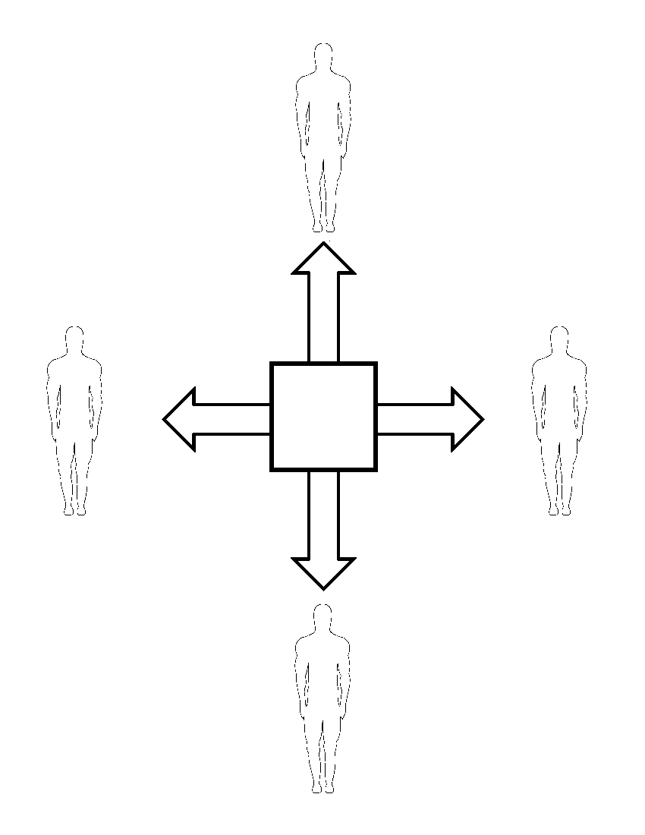

Forward/Up

Right

Left

Backward/Down

**Movement:** Use your hands to control the two collectors that appear on screen, by moving your hands in the direction you want them to go. Use your body to scroll the screen by moving left and right to scroll it horizontally and move forward to scroll it up and move back to scroll it down. Utilizing a scrolling screen allows a larger game area to be created and makes the game more interesting and challenging, since the player will have to search out the sphere that he needs, whilst avoiding the enemy spheres.

**Interaction:** To interact with the spheres on screen, move your hands together to activate the main collector, here you can collect a sphere by moving the main collector over it. Once you have collected a sphere, the main collector will change colour to match the one you are holding, so you always know what you are holding.

Now move around the game area to find a sphere of the same colour and size, be aware though, this will attract the enemy spheres to you and they will try to convert it to their own. To stop the enemy spheres from doing this, pull the left and right triggers on the controller to activate your blockers. Move your elbows to move the blockers into the path of the enemy spheres and bounce them away from you.

Once you have found a sphere of the same colour, move the main collector over to it and it and the sphere you are holding will merge, creating a larger sphere. Move your hands apart to deactivate the main collector and the enemy spheres will now leave you alone, now you can repeat the process with another set of spheres.

If you collect a medium, large or a giant sphere and you move it over to a smaller sphere of a different colour. It will change the colour of that one, to the one you are currently holding and add 1 to the score of the colour you have just created.



Main collector activated

Main collector de-activated

**Aims and goals**

To win the game you need to fill one of the coloured metres on either side of the screen, by changing the colours of smaller spheres into any chosen colour. This can be done with red, blue, green or yellow depending on your preference. But beware loosing spheres to the enemy spheres will increase the enemies’ life and decrease yours. If you lose too many spheres to the enemies and your health depletes, then it will be game over. then they will merge into a black hole and consume all spheres in the area and you will lose.

**Why I chose this game**

I chose this game because I wanted to create an abstract game that could be enjoyed by anyone, no matter what the age, gender or whether they’re a gamer. I chose an abstract game because in my opinion they work better on the 360 Kinect over traditional games such as shooters and action games. They are also more family friendly because they are very removed from day to day life and have very little tangibility, so it’s easier to forget about any troubles the player may be having. Also since the main audience for the Kinect is families and recreational gamers, I felt that they fit together very nicely.

**Comments**

Sphere collision and animation: As the spheres move around the screen, they will collide with each other and the edges of the game area, and bounce away. When the spheres hit the edges of the game area, they will temporarily stop moving and squish against the side. Once they have fully squished, they will start moving again a un-squish.

**References:**

Images:

Coloured spheres: <http://www.iluzion.ca/Anglais/HTML/promotion/mainpromotion.html>

Black spheres: <http://www.photosinbox.com/download/black-sphere.jpg>

Background: <http://www.learnthailanguage.org/wp-content/uploads/2013/02/Space-wallpaper-random-26646764-1600-1200.jpg>

Hand: <http://www.edupics.com/coloring-page-fist-dm22121.jpg>

Man: <http://www.fun-with-pictures.com/image-files/man-outline.png>

Menu background: <http://www.thatsreallypossible.com/wp-content/uploads/2012/12/Space-Colonialisation.jpg>

Options background: <http://fwallpapers.com/files/images/space-green-nebula.jpg>

Sounds:

Power up ray: <http://soundbible.com/1636-Power-Up-Ray.html>

Appear: <http://soundbible.com/1686-Appear.html>

Eye poke: <http://soundbible.com/2048-Eye-Poke.html>

Music: Tron Legacy soundtrack - End titles